The Queens 90th Birthday celebrations.

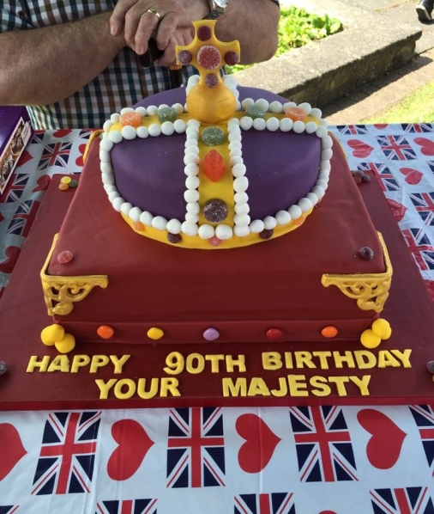

Well after having three celebrations on the village greens, to commemorate the Queens 90th Birthday, Datchet Parish Council would like to thank you all for supporting the events, and look forward to our next joint event, which will be Christmas on the Green 3rd December.

Gossip Green

The new benches have now been installed, the bins and notice boards should be in place by the time this issue goes to press.

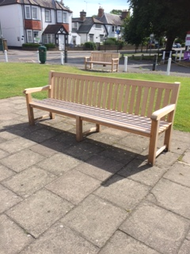

Plaques of Remembrance

Datchet Parish Council have now installed three plaques of remembrance, two are in the Datchet Library and one is the Village Hall entrance. The plaques are in memory of Denys Randolph, Edward 3rd Lord Montague of Beaulieu, and Patrick Simmons.

Datchet Village Hall

As reported in the 68th issue of The Link the Village Hall electrical system was checked, and all wiring that required urgent attention has been completed, plus the Audio Visual system is now up and running, and used for the August Datchet Parish Council meeting, so the public could hear all that was being said. Parish Council meetings will be recorded from September.

Cemetery

As reported in the 69th issue of The Link the gates at the Cemetery have now been repaired, the footpath installed and the boundary fence to the Eastern boundary should be fully installed by publication of this issue.

Litter / Fly Tipping

There has been many reports on Datchet Eye, with regard to the state of our village and the amount of litter/rubbish laying around, it's very important we all take a responsibility to ensure that our litter/rubbish is disposed of correctly, and use the bins provided and not just drop it. The bins provided by the Council for recycling should be used and not just Fly Tip your unwanted house hold items next to them, please take these unwanted items to the local tip or if they can be resold to the charity shop.

The Royal Borough of Windsor and Maidenhead offer "Adopt-a-Street" scheme, "Adopt-a-Street" encourages local people to volunteer to care for their communities and local environment through collecting litter from their local streets and areas. Volunteering for this scheme will not mean a reduction in the council's street cleaning schedules, it will complement and enhance this service. You can choose the area you want to "adopt" and when you want to volunteer. The council will help you by providing a litter picking kit, including a litter picker, gloves, tabard and bags, and basic written health and safety guidance is provided. It is a fantastic opportunity for all residents and other groups to get involved in looking after their local area.
"Adopt-a-Street is the perfect way of reinforcing the council's zero tolerance policy on litter. It also encourages a real sense of civic pride among volunteers in their own neighbourhoods".

River Front

Since the 68th & 69th issue of The Link, the River Front works are coming on, with the wall. path, lighting and water fountain now all competed, the refurbished benches, tree felling and grounds work are still in the process of being competed.

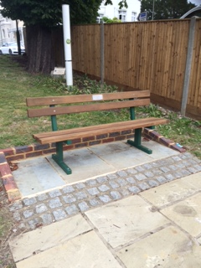

Flower Beds & Planters

The beds and planters have been replaced with summer plants and the hanging baskets are up, and looking outstanding as always, We took on board a suggestion that rather than just dig out the planting we could offer it to residents/organisations. So when the beds are replanted we will inform the residents where and when the plants will become available for collection.
We have also put in place a seven of new planters.

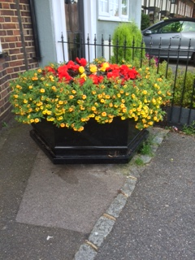

Datchet Flood Plan

Datchet Parish Council, have been working on a new, user friendly Flood Plan that will be uploaded to the website, which residents will understand and know what to do as and when and who to contact as and when.

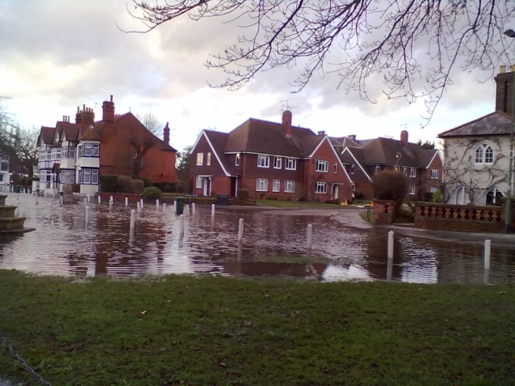

Datchet Parish Council

Datchet parish Council meetings take place on the 2nd Monday of each month starting at 7:30 in the village hall, fell free to come and join us.

