Datchet Parish Council

NAG. Horton, Wraysbury and Datchet are re-launching the NAG.
Neighbourhood Action Groups (NAGs) is a key part of Neighbourhood Policing in Thames Valley.
A NAG is a multi-agency, problem-solving group that consists of relevant partner agencies, key stakeholders and, most importantly, members of the local community.
NAGs focus their work around the main priorities that are identified after consultation with the local community. Members, who are all volunteers, take on responsibility for achieving certain tasks on behalf of their Neighbourhood.
NAGs attract a broad and diverse membership with a variety of skills and experience. The following partners will be considered to sit on a NAG:
- Local Authority/District Council representative.
- Youth service.
- Housing manager.
- Environmental officer.
- Parish councillor.
- Local Authority/Council councillor.
- Headteacher.
- Local business community member.
- Licensee.
- Neighbourhood Watch coordinator.
- Police (neighbourhood inspector, sergeant, constable, police community support officer).
- Neighbourhood members (minimum of three) – people known and respected by the local community.
- A minimum of two young people, aged between 14 and 16.
Once this has been in operation for a short time, we will also be looking at re-launching the Neighbourhood Watch Group. NHW.

Royal Borough Community Wardens.

Community wardens provide a reassuring presence, prevent crime and antisocial behaviour and help build safer communities.
Their role is varied one, and includes.
- Working closely with a range of partners including housing associations, the police and the voluntary and community sector.
- Reporting suspicious behaviour to the police.
- Tackling environmental problems such as littering and graffiti.
- Issuing Fixed Penalty Notices for a range of offences.
- Providing advice and information on a range of council services.
- Supporting vulnerable people in the community.
- Visibly patrolling their areas and engaging with residents.

You can contact the Wardens on 01628 685636, email: wardens@rbwm.gov.uk

Police Community Support Officers

(PCSOs) perform a fantastic public service for their local community.

Police Community Support Officers are uniformed staff whose role is primarily to support the work of police officers. They assist the police in areas which demand a certain level of police presence, but does not necessarily require the expertise of a trained police officer. An example of this would be in a predominantly rural location where the crime rate is low, yet a presence is still required for situations such as anti-social behaviour and minor occurrences of criminal damage.
Our PSCO Officers are:
C9244 Les Bradfield
C3214 Alexander Alderson.

With this all this in place it should make Datchet a safer and a nicer place to live, we have all seen or heard of some of the vile incidents which have taken place within our village, let's put a stop to it now.

Info Board on Gossip Green. If you want to put something up in there, please liaise with the Parish Council Office.

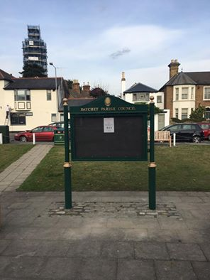

All works to Gosip Green have been completed. New Notice Board, Benches and Bins, the new flower planter will be in place by the time this goes to press. All that is required now is the Posts to be cleaned.

***CHRISTMAS IN DATCHET - SAT 3 DEC 2PM to 9.30PM***
our BIGGEST festive community event ever!!
St.Mary's Church...2pm to 6pm
ST.NICHOLAS FAYRE - lots of stalls & Father Christmas
TEA WITH FATHER CHRISTMAS ...

