One year on and I wish to thank the hard work and dedication of the councillors. Within the year we have seen some changes.

Datchet Village Society visit cemetery chapel
History buffs enjoyed a special visit with the Datchet Village Society (DVS) on Sunday, March 20. Since the visit we have had a resident come forward who would like to support us with how we can put this Grade I listed build into use.

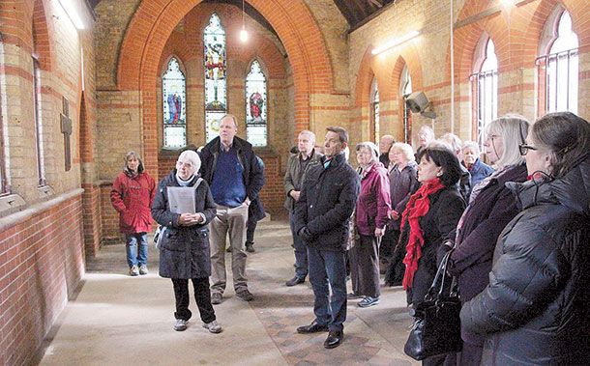

Queens 90th Birthday celebrations

A specially commissioned beacon in the shape of a silver rose was blessed by Rev. Wyard, and lit by Cllr Jo Stickland on the 12st April. Thanks to Cllr Kate Fitzgerald for organising this very successful event.

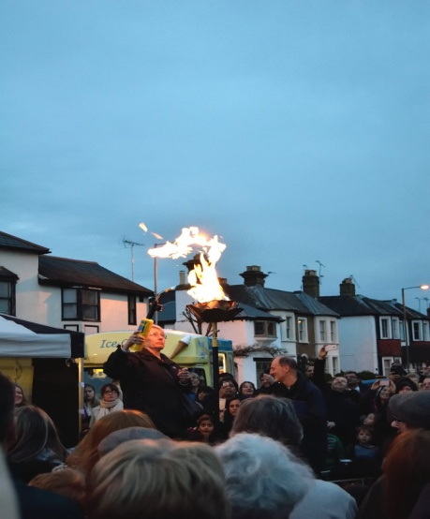

The River Front
The wall, footpath, lighting, water fountain and kerbing have been completed thanks to the Royal Borough Windsor & Maidenhead and the Barker Bridge House Trust for their funding.
The benches have been refurbished and awaiting installation once the land is grassed over and new picnic area to be installed.

Cemetery
A new footpath the complete length of the eastern boundary has been installed, we are now looking into the costing of a boundary fence to finish off.

Gossip Green
Is the next area for a facelift, we are going to install new benches, bins, notice board and planter.

This will then roll out to all the greens so the will have the same type of sheet furniture.

Byelaws
These have now been sent to be ratified, once they return we will be putting up notices around the land which the Parish owns or manages, so people know what it permitted and what is not permitted

Neighbourhood Plan
Our first meeting has been held, we have a strong group of people come forward to work on the group so we should have something to report by the next issue of the Link

Datchet Village Pharmacy
Datchet Parish Council support residents and the pharmacy and we need you all to write individual letters to the local MP
Adam Afriyie stating the need of having a pharmacy in Datchet.

Jetties
When Riverfront works are completed will call a public meeting in relation to the jetties.
The Lead Member for Finance
Cllr Harry Clasper reminds us that the Precept was left the same as the previous year. There was an end of year surplus of £68,115 which would be carried forward into this financial year. £10,000 had been transferred to the reserve account to bring this up to £70,000. The net worth of the council was £202,475.

The Lead Member for Grounds
Cllr Gary Muir, thanks the grounds team and a copy of a full report is available from the Parish Office.
York Stone has be laid underneath the benches at the Riverfront with a red brick to retain the soil and an opening ceremony will be taking place soon.
The work which has already taken place is a great thing for the Village.

The Lead Member for Highways and General Purposes
Cllr J. Grey, knows that there are problems with the drains in the High Street and is looking into what can be done to resolve these issues, he also is looking at the problems with pot holes in the main roads, any highways problems should be reported to Cllr Grey and with regard to the problem of pollution with standing traffic at the level crossing within the village. It is suggested that ‘we turn off our engine’ and that signs could be installed.

Anti Social behaviour.
Datchet Parish Council along with the PCSOs would like you to report any problems directly with the Police and not post on social media.

Damage to equipment
Please also watch out for damage to equipment, and advise the Datchet Parish Office of any damage to Parish property.

Fly tipping
Fly tipping / littering is also becoming an issue around the village, please take your rubbish home and dispose of it carefully.
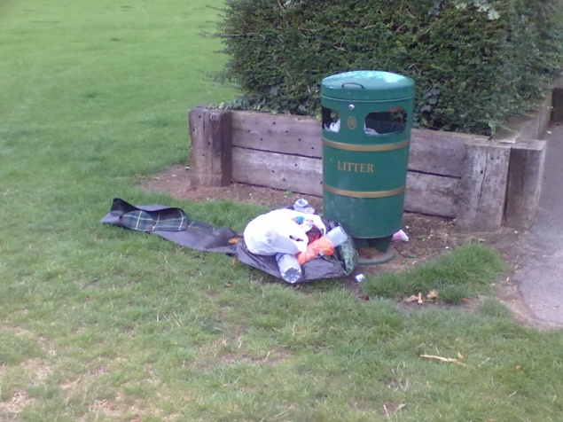

The bin area in the car park is not for dumping rubbish, unless you can put it in a bin provided and not beside it.

DATCHET PARISH COUNCIL MEETINGS 2016/2017
Meetings are held on the 2nd Monday of the month starting at 7.30pm
Feel free to come and join us.

