Datchet Parish Council is putting together a working group to draw up a Neighbourhood Plan, please see the information below. If you would like to join us please contact the Parish office.

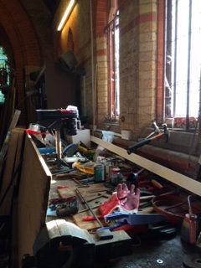

A questionnaire will be coming through your door in the very near future, please ensure that all members of your household complete the questionnaire. Should you require extra copies they will be available from the Parish Office.

The most important financial event of the year is the setting of the Annual Precept for the forthcoming financial year (April to March).

The Precept is the local tax levied by the Parish Council and collected by the Borough Council as part of the Council Tax. The money is used for the upkeep and improvement of the Village facilities, such as our open spaces and properties.
The Precept is set each year in January and this was actioned at the Council meeting on January 11th based upon a budget of expected expense and revenue for the year 2016/17. The Council decided that the Precept would remain unchanged at £176,650.

More details of the Council’s spending plans will be published when the Council Tax demands are issued.

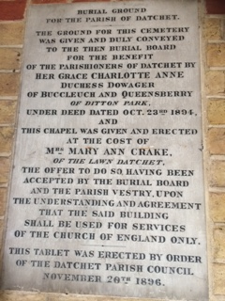
Datchet Chapel at the cemetery in Ditton Road is in the process of being cleared, and put back into service as it was left to us by Mrs Mary Ann Crake

Also the repairs to the Cemetery gates is close to completion. Further works planned for the cemetery is the installation of a footpath to the eastern boundary.

Anti Social Behaviour, around the village, is becoming more frequent. Should you see anything, please do not just put your concerns on Datchet Eye but also inform the Police. Over the past few months, the Parish Council have incurred two break-ins, plus damage to the play equipment. This has an impact upon you as parishioners as the play equipment is then out of service, plus jobs around the village are delayed due to the loss of equipment.

Benches. The benches on the riverside have been removed and will be sent for refurbishment. A survey has been carried out of all the benches in the village and a staggered refurbishment program will be implemented, starting with Memorial Green.

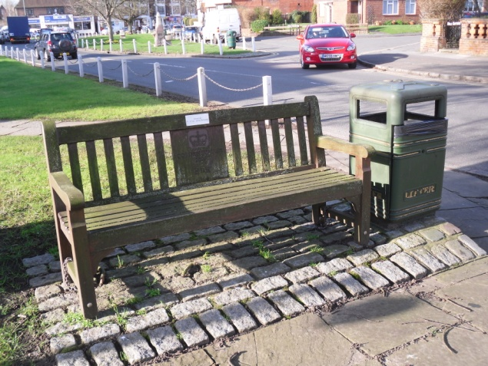

Litter bins. A detailed survey will be carried out to determine which bins need to be replaced or refurbished. All the bins in the village can be used for Dog waste, therefore, there should be no reason to see Dog waste within the village. The Parish council also provides Dog Bins, with bags in the village and on the recreation ground.

Mill Place / Willowfields. In the next few weeks the area will be cleared of fly tipped materials.

Clean for The Queen for Her Majesty's 90th birthday
“Everyone has a responsibility to keep their community tidy and this campaign provides us with a great chance to protect our wildlife and improve the quality of our streets and public spaces. I hope it will help lead to a lasting legacy of a cleaner, tidier Datchet." Clean for the Queen is taking place on the weekend of 4th to 6th March 2016 so if you would like to join our campaign to clean Datchet, please join in by clearing the area around your house , street or village centre.

River Front work has started, the first stage being the installation of steel pilings.

Once the River front wall is complete, the Parish Council will then go out for consultation with regard to Jetties.

Datchet Parish Council website, is being up graded, in conjunction with a facebook account and twitter, with this in mind we are hoping that residents will provide us a supply of photos which can be used on the website,

